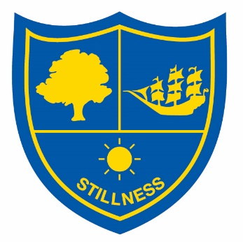

Stillness Junior School   
Brockley Rise   
London   
SE23 1NH

*“Our Best At all Times”*

**Feedback Form**

Name:

E-Mail Address:

Telephone Number:

Your Feedback: